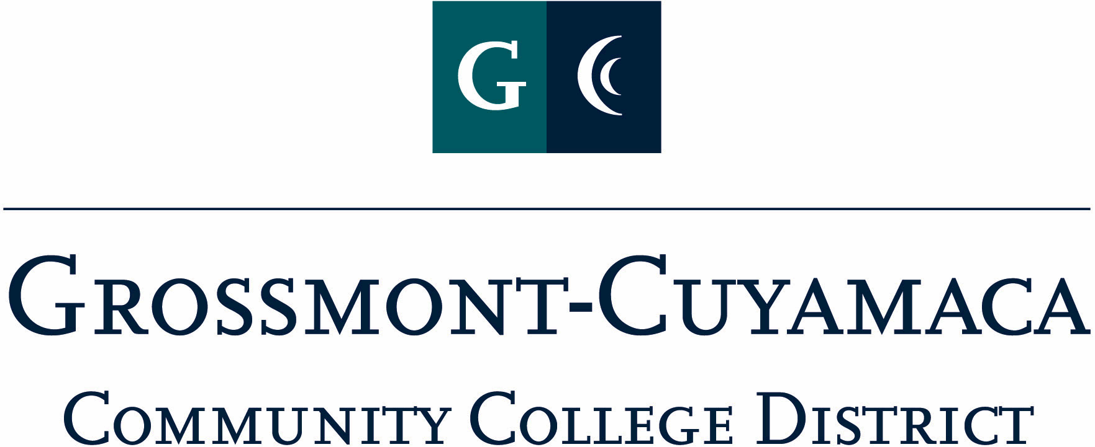

CLASSIFIED SENATE
EXECUTIVE BOARD MEETING
July 13, 2010– Meeting Minutes

Members Present: Debi Miller, Paula Tillery, Maggie Gonzales, Avelina Wilder, Kimberly Gioscia, Wendy Corbin, Yvette Macy, Maria Briney, Angela Johnson, JacQueline Osborne, Pat Murray, Karen McCoy
Members Absent: Monica Farris
Members Excused: Tasa Campos, Patricia Bailey, Scott Howell, Karen Ostegard, Jean Wallace

1. Welcome and Call to Order

The meeting was called to order at 12:02p.

2. Approval of Minutes from May 4, 2010 and June 1, 2010

The minutes from May 4, 2010 meeting were approved. M/S/A Gioscia/Wilder. Motion passed.
The minutes from June 1, 2010 meeting were approved. M/S/A Gonzales/Gioscia. Motion passed.

3. Communication

VP Reports

District: Wendy Corbin reported:
- Planning & Budget Jam Committee: the classified representatives on this newly formed committee will be Sara Fralick and Amy Leisure. Wendy Corbin added that they have forwarded to her the notes taken and she will make those available on our website. She further explained that the meeting was organizational in nature and included schedule, tasks, district representation, committee composition.
- Safety Committee: The committee is working to tactfully incorporate Evacutracs-AED as part of the compliance list. They will also be upgrading the training schedules for staff.
- Benefit Committee: There was an informal session that included a structure change description and new approval process for benefits. She will send the minutes from this meeting as well.

Grossmont: Pat Murray reported:
- The peripheral road around campus will be closed from 11p-6a daily once the gates are installed.
- Leadership Meeting: there was a discussion on the recent comments by Rick Alexander at the June 2010 Board meeting and the GC Student trustee (Christopher Enders) about the student body at GC as a corporation.
- 50 Year Anniversary: the college will be rolling out references to the upcoming 50 year anniversary of Grossmont College throughout the year
- Professional Dev Workshop: In accordance with the GC Strategic Plan, the staff will be offered a workshop prior to flex week on following up to planning items.
- Kerry Cleaver is the new Dean.

Cuyamaca: Maggie Gonzales reported:
- Del Mar Fair: the district offers a yearly presence at the fair. Next year a formal announcement will be disseminated to all classified for their interest in being a rep at the fair, with supervisor permission. Maggie will be the facilitator of the volunteer list.
- Lunch winners from CSAD: Maggie inquired if there had been any follow-up with the recipients of the lunch. She encouraged the other VPs to follow-up with their winners to get their feedback.

President’s Report: Debi Miller asked for a vote on the following Motions:
- Motion to Reinstate 8/3 Meeting due to the rescheduling of the Classified Senate Retreat to 9/24/10. M/S/A Corbin/McCoy. Motion passed.
- Motion to approve the GCCCD Classified Senate Executive Board 2010-2011 meeting calendar. M/S/A Gonzales/Murray. Motion passed.
- DEC: Debi Miller will be serving as a classified representative on the task force to review the district shared governance handbook.
- Classified Senate Retreat 9/24/10: the release time documents will be sent out this month for those who will be attending the retreat.

Treasurer Report: Paula Tillery reviewed the Treasurer’s report with the group. She indicated that the expense of $145.28 recorded in the trust was an expense of the CSAD budget and an expense transfer needed to be made. She will also check on the donations for CSAD that were listed on the trust budget report to see if they have in fact been transferred over to the CSAD budget.

4. Continuing Business:

CSAD Budget: The group reviewed the CSAD budget that was generated.

Mother Goose Parade Update: Wendy Corbin and Yvette Macy will be sending a business proposal for President Miller to review before disseminating to the E-Board for their input.

BBQ Fundraiser: Tabled.

The meeting adjourned at 12:45p.

